**Question 2: Use Webscraping to Extract Tesla Revenue Data**

Use the requests library to download the webpage <https://cf-courses-data.s3.us.cloud-object-storage.appdomain.cloud/IBMDeveloperSkillsNetwork-PY0220EN-SkillsNetwork/labs/project/revenue.htm> Save the text of the response as a variable named html_data.

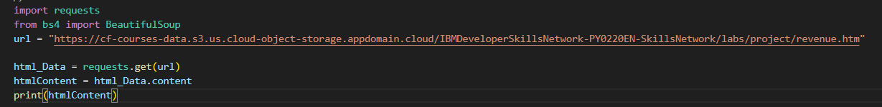

**Parse the html data using beautiful_soup.**

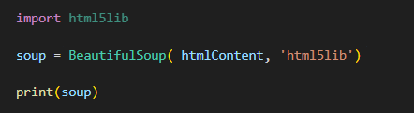

Using BeautifulSoup or the read_html function extract the table with Tesla Revenue and store it into a dataframe named tesla_revenue. The dataframe should have columns Date and Revenue.

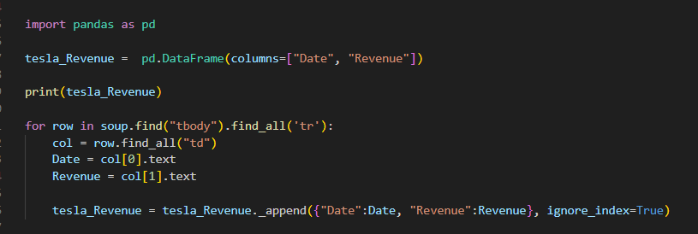

Display the last 5 row of the tesla_revenue dataframe using the tail function. Take a screenshot of the results.

